Algebra 2 Syllabus

## Dear Algebra 2 Students and Parents Thereof,

I am excited to be teaching and working with you at Ferndell School this year. In addition to teaching, my interests include hiking, fishing, playing piano, twirling and dancing. My own continuing mission as a teacher is to foster a lifelong love of learning and to help you find your own passion in life. This year, I am eager to create great relationships with each of you and help us create a culture of learning where we may all create quality work!

## Required Equipment

Like carpenters who need to bring their tools to the job, you will need to bring your own tools as students. The following is a list of equipment needed to discover, explore and understand mathematics. Bring them to class each day unless otherwise stated.

1. Notebook Paper
2. A folder for keeping homework in

## Attendance & Tardiness

As in college or at a career, you are expected to arrive to class prepared and on time each day. If you are absent, you are responsible for making up missed assignments. If you are aware that you are going to be absent, please plan ahead by using your syllabus and asking me or other students what assignments you will miss.

Homework

As a performing musician and dancer, I’ve always valued practice. Clearly, to be good at anything in life, one needs to practice, practice, and practice! Homework provides daily practice essential for developing mathematical understanding of the concepts introduced in class. Homework is assigned nearly every day and is due at the **beginning** of the following class period. Your homework assignments will be graded up to 100 points on the following criteria:

Accuracy: (30 points)

30 = 90% or more correct

15= 70% to 90% correct

0 = less than 70% correct

• No credit is given if less than 70% of the assignment is completed.

Completion: (50 points)

50 = detailed steps and diagrams are shown on every appropriate problem

30 = some work is shown on appropriate problems, some steps may have been omitted

0 = no work is shown on assignment

Timely: (10 points)

10= assignment was completed on day it was due.

5= assignment was one day late.

0 = assignment was more than one day late.

Neatness: (5 points)

5 = neat, easy to read, and models beautiful work

3 = adequate, legible, but may have some cross-outs

0 = illegible and little care was demonstrated

Name and Title: (1 point)

1 = name, class period, my name, and assignment name is written at the top right of the assignment.

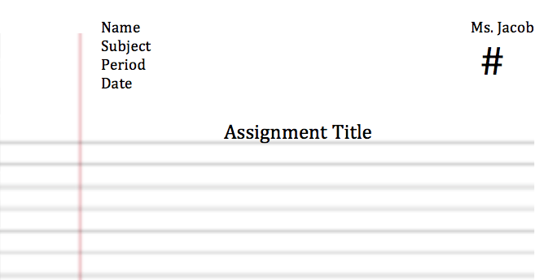

Date:

## Grades

Your grade each quarter is calculated as follows: 50% homework and quizzes and 50% tests.

## Classroom Principles

Five general principles guide our work together:

1. Be respectful.
2. Be courteous.
3. Be prepared.
4. Treat others as you wish to be treated.
5. Try your best at all times.

## Final Notes

Please complete and return the last page. Students should know that I am happy to give any extra help that I can. No question is too small. Many parents find email to be a great way to keep in touch with me. Feel free to e-mail me at victoria.scherer@fortbendisd.com If students, teachers, and parents work together closely, the possibilities and the results will be marvelous. I look forward to working with you and giving you the best education that we can offer.

Sincerely,

Victoria Scherer